

TEST REPORT

Doc No: HTPL/FOR/ENGG/TR01
Ver: 1.2

DOCUMENT DETAILS

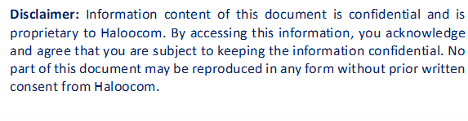

HTPL/FOR/ENGG/TR01
SOFTWARE TEST REPORT

OVERVIEW
Testing was completed by Sauravi and Mehul on June 16, 2025. Two critical issues were identified:
The objective was to implement and verify the client request for Yogmaya Hexa, where a dashboard with date-range filter functionality needed to be created along with Call_log report and voice logger report modules.

SOFTWARE IDENTIFICATION
- Name: Call Centre Software.
- Module Name: Dashboard & Reporting Module.
- Version: 1.2

TEST DATES & DURATION
- Test Start Date: June 16, 2025
- Test Completion Date: June 16, 2025
- Test Duration: 1 day
- Test Effort: 2 person-days

TEST RESOURCES
People Involved
- Test Lead: Sauravi
- Test Analyst: Mehul
- Development Lead: Nagendra
- Developer: Sauravi

ISSUES RAISED
Bug ID | Description | Severity | Status
BUG_001 | Dashboard with date-range filter functionality is not available, preventing users from viewing filtered analytics and performance metrics for specific time periods. | Low | Open

BUGS FIXED
Bug ID | Description | Fix Details | Status
BUG_001 |  | Created comprehensive dashboard with date-range filter functionality. Implemented interactive date picker with from/to date selection. Developed real-time data visualization charts and KPI widgets. Added filter logic to dynamically update dashboard metrics based on selected date range. | ✅ Fixed
  Dashboard with date-range filter functionality is not available, preventing users from viewing filtered analytics and performance metrics for specific time periods.

ADDITIONAL DETAILS
What Was Tested
- Dashboard date-range filter functionality and user interface.
- Call_log report data accuracy and completeness.
- Voice logger report functionality.
Summary
- Issue Identified: Missing dashboard with date-range filtering capability.
- Severity: Low.
- Status: Resolved
Workaround
- NA (Fixed in code directly)
Recommendation
Consider implementing advanced dashboard features such as drill-down capabilities, custom widget configuration, and scheduled report delivery. Add comparative analytics between different date ranges and implement dashboard sharing functionality. Enhance voice logger reports with audio quality analytics and storage optimization recommendations. Consider adding real-time alerts and notifications based on dashboard metrics.
APPROVALS
Approver | Signature | Date

